Bahria University,

Karachi Campus



LAB EXPERIMENT NO.

01

LIST OF TASKS

|  |  |
| --- | --- |
| TASK NO. | OBJECTIVE |
| 1 | Make a 5 page website, including home page, linked altogether having header and footer section mandatorily. Web pages should cover all the html tags overall eg: make a gallery page with the help of table tag and insert images in that. |

Submitted On:

**Task 1:** Make a 5 page website, including home page, linked altogether having header and footer section mandatorily. Web pages should cover all the html tags overall, eg: make a gallery page with the help of table tag and insert images in that.

**Solution:**

Index.html:

<!DOCTYPE html>

<html lang="en">

<head>

<meta charset="UTF-8">

<meta http-equiv="X-UA-Compatible" content="IE=edge">

<meta name="viewport" content="width=device-width, initial-scale=1.0">

<link rel="preconnect" href="https://fonts.googleapis.com">

<link rel="preconnect" href="https://fonts.gstatic.com" crossorigin>

<link rel="stylesheet" href="/CSS/style.css">

<title>Home | Lacoste</title>

</head>

<body>

<header id="header">

<div class="logo">

<img src="/Images/logo.png" alt="logo" class="logo-img" width="75px">

<h1 class="logo-text">Lacoste</h1>

</div>

<nav id="navbar" class="navbar">

<ul class="nav-links" style="list-style-type: none;">

<li><a class="nav-link active" href="index.html">Home</a></li>

<li><a class="nav-link" href="clothing.html">Clothing</a></li>

<li><a class="nav-link" href="about.html">About</a></li>

<li><a class="nav-link" href="contact.html">Contact</a></li>

</ul>

<a href="register.html" class="cta"><button>Join Us</button></a>

</nav>

</header>

<section id="hero">

<div class="row">

<h1 class="main-text">Discover the Latest Trends in Town!</h1>

<h2 class="sub-text">Polos, sweatshirts, dresses... they're flying off the shelves. So get yours.</h2>

<img class="bg" src="/Images/bg-1.jpg" alt="image">

</div>

</section>

<footer id="footer">

<div class="footer-content">

<ul class="social" style="list-style-type: none;">

<li><a href="#"><img src="/Images/facebook.svg" alt="icon" width="12px"></a> &nbsp;&nbsp; |</li>

<li><a href="#"><img src="/Images/instagram.svg" alt="icon" width="17px"></i></a> &nbsp;&nbsp; |</li>

<li><a href="#"><img src="/Images/twitter.svg" alt="icon" width="17px"></i></a> &nbsp;&nbsp; |</li>

<li><a href="#"><img src="/Images/google-plus.svg" alt="icon" width="24px"></i></a> &nbsp;&nbsp; |</li>

<li><a href="#"><img src="/Images/linkedin.svg" alt="icon" width="15px"></i></a></li>

</ul>

<p>copyright &copy;2022. Designed by <span>Abdul Basit</span></p>

</div>

</footer>

</body>

</html>

Clothing.html:

<!DOCTYPE html>

<html lang="en">

<head>

<meta charset="UTF-8">

<meta http-equiv="X-UA-Compatible" content="IE=edge">

<meta name="viewport" content="width=device-width, initial-scale=1.0">

<link rel="preconnect" href="https://fonts.googleapis.com">

<link rel="preconnect" href="https://fonts.gstatic.com" crossorigin>

<link rel="stylesheet" href="/CSS/clothing.css">

<title>Clothing | Lacoste</title>

</head>

<body>

<header id="header">

<div class="logo">

<img src="/Images/logo.png" alt="logo" class="logo-img" width="75px">

<h1 class="logo-text">Lacoste</h1>

</div>

<nav id="navbar" class="navbar">

<ul class="nav-links" style="list-style-type: none;">

<li><a class="nav-link" href="index.html">Home</a></li>

<li><a class="nav-link active" href="clothing.html">Clothing</a></li>

<li><a class="nav-link" href="about.html">About</a></li>

<li><a class="nav-link" href="contact.html">Contact</a></li>

</ul>

<a href="register.html" class="cta"><button>Join Us</button></a>

</nav>

</header>

<section id="gallery">

<div class="row">

<h1 class="main-text">The Lacoste World!</h1>

<table>

<tr class="firstRow">

<td>

<img src="/Images/shirt-1.jpg" alt="img" width="400px">

</td>

<td>

<img src="/Images/shirt-4.jpg" alt="img" width="400px" style="position: relative; left: 35px;">

</td>

<td>

<img src="/Images/shirt-3.jpg" alt="img" width="370px">

</td>

</tr>

<tr class="secondRow">

<td>

<img src="/Images/shirt-6.jpg" alt="img" width="340px" style="position: relative; left: 35px;">

</td>

<td>

<img src="/Images/shirt-5.jpg" alt="img" width="470px" style="position: relative; left: 10px;">

</td>

<td>

<img src="/Images/shirt-2.png" alt="img" width="470px" style="position: relative; left: -40px;">

</td>

</tr>

</table>

</div>

</section>

<footer id="footer">

<div class="footer-content">

<ul class="social" style="list-style-type: none;">

<li><a href="#"><img src="/Images/facebook.svg" alt="icon" width="12px"></a> &nbsp;&nbsp; |</li>

<li><a href="#"><img src="/Images/instagram.svg" alt="icon" width="17px"></i></a> &nbsp;&nbsp; |</li>

<li><a href="#"><img src="/Images/twitter.svg" alt="icon" width="17px"></i></a> &nbsp;&nbsp; |</li>

<li><a href="#"><img src="/Images/google-plus.svg" alt="icon" width="24px"></i></a> &nbsp;&nbsp; |</li>

<li><a href="#"><img src="/Images/linkedin.svg" alt="icon" width="15px"></i></a></li>

</ul>

<p>copyright &copy;2022. Designed by <span>Abdul Basit</span></p>

</div>

</footer>

</body>

</html>

About.html:

<!DOCTYPE html>

<html lang="en">

<head>

<meta charset="UTF-8">

<meta http-equiv="X-UA-Compatible" content="IE=edge">

<meta name="viewport" content="width=device-width, initial-scale=1.0">

<link rel="preconnect" href="https://fonts.googleapis.com">

<link rel="preconnect" href="https://fonts.gstatic.com" crossorigin>

<link rel="stylesheet" href="/CSS/about.css">

<title>About | Lacoste</title>

</head>

<body>

<header id="header">

<div class="logo">

<img src="/Images/logo.png" alt="logo" class="logo-img" width="75px">

<h1 class="logo-text">Lacoste</h1>

</div>

<nav id="navbar" class="navbar">

<ul class="nav-links" style="list-style-type: none;">

<li><a class="nav-link" href="index.html">Home</a></li>

<li><a class="nav-link" href="clothing.html">Clothing</a></li>

<li><a class="nav-link active" href="about.html">About</a></li>

<li><a class="nav-link" href="contact.html">Contact</a></li>

</ul>

<a href="register.html" class="cta"><button>Join Us</button></a>

</nav>

</header>

<section id="about">

<div class="row">

<h1 class="main-text">About Us</h1>

<p class="sub-text">At the crossroads of sport and fashion, Lacoste librates and creates movement in each person’s life by encouraging self-expression. In each collection and every line, the timeless elegance of Lacoste is captured by a combination of creativity and tradition. A blend that enables everyone to develop their personal style by absorbing and reinterpreting the brand’s rich heritage. By making it their own. The aura of the crocodile is reinforced with every generation that wears it, becoming a sign of unity that goes beyond style. Passed down from country to country and through the generations, from one friend to another, Lacoste clothing is steeped in emotional ties that promote it to icon status.</p>

<p class="sub-text sub-text2">In a world that often highlights things that separate us, the Lacoste elegance brings us together. It unites those who are looking for a different path through life. Both universal ad timeless, it crosses cultures, oceans and generations to leave its mark on each and every person. Elegance transcending differences. Universal, accessible to all. A creative, inventive elegance that allows you to play and to dare. And which inspires us to go beyond established norms to invent our own lives while remaining faithful to who we really are. Lacoste invites you to realise your dreams, but not on your own. Instead, by joining a wider community in which everyone respects and recognises each other’s elegance.</p>

</div>

</section>

<footer id="footer">

<div class="footer-content">

<ul class="social" style="list-style-type: none;">

<li><a href="#"><img src="/Images/facebook.svg" alt="icon" width="12px"></a> &nbsp;&nbsp; |</li>

<li><a href="#"><img src="/Images/instagram.svg" alt="icon" width="17px"></i></a> &nbsp;&nbsp; |</li>

<li><a href="#"><img src="/Images/twitter.svg" alt="icon" width="17px"></i></a> &nbsp;&nbsp; |</li>

<li><a href="#"><img src="/Images/google-plus.svg" alt="icon" width="24px"></i></a> &nbsp;&nbsp; |</li>

<li><a href="#"><img src="/Images/linkedin.svg" alt="icon" width="15px"></i></a></li>

</ul>

<p>copyright &copy;2022. Designed by <span>Abdul Basit</span></p>

</div>

</footer>

</body>

</html>

Contact.html:

<!DOCTYPE html>

<html lang="en">

<head>

<meta charset="UTF-8">

<meta http-equiv="X-UA-Compatible" content="IE=edge">

<meta name="viewport" content="width=device-width, initial-scale=1.0">

<link rel="preconnect" href="https://fonts.googleapis.com">

<link rel="preconnect" href="https://fonts.gstatic.com" crossorigin>

<link rel="stylesheet" href="/CSS/contact.css">

<title>Contact | Lacoste</title>

</head>

<body>

<header id="header">

<div class="logo">

<img src="/Images/logo.png" alt="logo" class="logo-img" width="75px">

<h1 class="logo-text">Lacoste</h1>

</div>

<nav id="navbar" class="navbar">

<ul class="nav-links" style="list-style-type: none;">

<li><a class="nav-link" href="index.html">Home</a></li>

<li><a class="nav-link" href="clothing.html">Clothing</a></li>

<li><a class="nav-link" href="about.html">About</a></li>

<li><a class="nav-link active" href="contact.html">Contact</a></li>

</ul>

<a href="register.html" class="cta"><button>Join Us</button></a>

</nav>

</header>

<section id="contact">

<div class="container">

<div class="contact-box">

<div class="contact-left">

<h3 class="main-text">Send Your Request!</h3>

<form action="#">

<div class="input-row">

<div class="input-group">

<label for="name">Name</label>

<input type="text" id="name" name="name" placeholder="Name">

</div>

<div class="input-group">

<label for="ph">Phone</label>

<input type="number" id="ph" name="num" placeholder="Phone Number">

</div>

</div>

<div class="input-row">

<div class="input-group">

<label for="email">Email Address</label>

<input type="email" id="email" name="email" placeholder="Email Address">

</div>

<div class="input-group">

<label for="sub">Subject</label>

<input type="text" id="sub" name="sub" placeholder="Subject">

</div>

</div>

<label for="tArea">Message</label>

<textarea name="msg" id="tArea" rows="5" placeholder="Your Message"></textarea>

<div class="row button">

<input type="button" value="Send">

</div>

</form>

</div>

</div>

</div>

</section>

<footer id="footer">

<div class="footer-content">

<ul class="social" style="list-style-type: none;">

<li><a href="#"><img src="/Images/facebook.svg" alt="icon" width="12px"></a> &nbsp;&nbsp; |</li>

<li><a href="#"><img src="/Images/instagram.svg" alt="icon" width="17px"></i></a> &nbsp;&nbsp; |</li>

<li><a href="#"><img src="/Images/twitter.svg" alt="icon" width="17px"></i></a> &nbsp;&nbsp; |</li>

<li><a href="#"><img src="/Images/google-plus.svg" alt="icon" width="24px"></i></a> &nbsp;&nbsp; |</li>

<li><a href="#"><img src="/Images/linkedin.svg" alt="icon" width="15px"></i></a></li>

</ul>

<p>copyright &copy;2022. Designed by <span>Abdul Basit</span></p>

</div>

</footer>

</body>

</html>

Register.html:

<!DOCTYPE html>

<html lang="en">

<head>

<meta charset="UTF-8">

<meta http-equiv="X-UA-Compatible" content="IE=edge">

<meta name="viewport" content="width=device-width, initial-scale=1.0">

<link rel="preconnect" href="https://fonts.googleapis.com">

<link rel="preconnect" href="https://fonts.gstatic.com" crossorigin>

<link rel="stylesheet" href="/CSS/register.css">

<title>Signup | Lacoste</title>

</head>

<body>

<header id="header">

<div class="logo">

<img src="/Images/logo.png" alt="logo" class="logo-img" width="75px">

<h1 class="logo-text">Lacoste</h1>

</div>

<nav id="navbar" class="navbar">

<a href="index.html" class="cta active"><button>Back</button></a>

</nav>

</header>

<div class="heading">

<h1 class="main-text">Connect With Us!</h1>

</div>

<section class="container">

<h2 class="sub-text">Sign Up</h2>

<form action="#">

<div class="row">

<label for="fname">First Name</label>

<input type="text" placeholder="First Name" name="myFirstName" id="fname" required>

</div>

<div class="row lastName">

<label for="lname">Last Name</label>

<input type="text" placeholder="Last Name" name="myLastName" id="lname" required>

</div>

<div class="row">

<label for="dob">Birthday</label>

<input type="date" name="myDob" id="dob" required>

</div>

<div class="rowx">

<label for="gender">Gender</label>

<div class="genbox">

<input type="radio" name="myGen" id="gender"> <span class="gen">Male</span>

<input type="radio" name="myGen" id="gender"> <span class="gen">Female</span>

</div>

</div>

<div class="row">

<label for="email">Email</label>

<input type="email" placeholder="Email Address" name="myEmail" id="email" required>

</div>

<div class="row pNumber">

<label for="phone">Phone Number</label>

<input type="number" placeholder="Phone Number" name="myNumber" id="phone" required>

</div>

<div class="row subject">

<label for="option">Country</label>

<select name="opt" id="option" required>

<option value="#">Choose Option</option>

<option value="ITL">Italy</option>

<option value="FRA">France</option>

<option value="SWE">Sweden</option>

</select>

</div>

<div class="row button">

<input type="button" value="Submit">

</div>

</form>

</section>

<footer id="footer">

<div class="footer-content">

<ul class="social" style="list-style-type: none;">

<li><a href="#"><img src="/Images/facebook.svg" alt="icon" width="12px"></a> &nbsp;&nbsp; |</li>

<li><a href="#"><img src="/Images/instagram.svg" alt="icon" width="17px"></i></a> &nbsp;&nbsp; |</li>

<li><a href="#"><img src="/Images/twitter.svg" alt="icon" width="17px"></i></a> &nbsp;&nbsp; |</li>

<li><a href="#"><img src="/Images/google-plus.svg" alt="icon" width="24px"></i></a> &nbsp;&nbsp; |</li>

<li><a href="#"><img src="/Images/linkedin.svg" alt="icon" width="15px"></i></a></li>

</ul>

<p>copyright &copy;2022. Designed by <span>Abdul Basit</span></p>

</div>

</footer>

</body>

</html>

Style.css:

@import url('https://fonts.googleapis.com/css2?family=Montserrat:wght@500&display=swap');

@import url('https://fonts.googleapis.com/css2?family=Roboto&display=swap');

@import url('https://fonts.googleapis.com/css2?family=Raleway&display=swap');

@import url('https://fonts.googleapis.com/css2?family=Metrophobic&display=swap');

*{

margin: 0;

padding: 0;

box-sizing: border-box;

}

body{

height: 100vh;

overflow-x: hidden;

}

.logo-text{

color: black;

font-family: 'Metrophobic', sans-serif;

display: inline;

font-size: 26px;

font-weight: 600;

position: relative;

top: -12px;

left: -60px;

}

.logo-img{

position: relative;

top: 1px;

left: -65px;

}

li, a, button{

font-family: 'Roboto', sans-serif;

font-weight: 500;

font-size: 17px;

color: black;

text-decoration: none;

}

header{

display: flex;

justify-content: flex-end;

align-items: center;

padding: 30px 10%;

}

#header{

background-color: #edf0f1;

height: 80px;

z-index: 997;

transition: all 0.6s;

box-shadow: 0px 2px 15px rgba(0, 0, 0, 0.4);

}

.logo{

cursor: pointer;

margin-right: auto;

position: relative;

left: 5px;

}

.nav-links{

position: relative;

left: -17px;

}

.nav-links li{

display: inline-block;

padding: 0px 19px;

}

.nav-links li a{

transition: all 0.5s ease 0s;

}

.nav-links li a:hover{

color: #0a5163;

text-decoration: underline;

}

.nav-links li a.active{

color: #0a5163;

text-decoration: underline;

}

button{

padding: 8px 25px;

background-color: rgb(7, 124, 34);

border: none;

border-radius: 50px;

cursor: pointer;

transition: all 0.3s ease 0s;

margin-left: 20px;

margin-right: -40px;

color: white;

font-family: 'Roboto', sans-serif;

font-weight: 500;

font-size: 15px;

}

button:hover{

background-color: rgba(3, 155, 61, 0.9);

}

.cta{

position: absolute;

top: 24px;

right: 92px;

}

.main-text{

color: black;

font-family: "Raleway", sans-serif;

position: relative;

top: 200px;

margin: 0 0 10px 130px;

font-size: 40px;

font-weight: 700;

line-height: 56px;

}

.sub-text{

color: black;

font-family: "Raleway", sans-serif;

position: relative;

margin: 5px 0 10px 130px;

margin-bottom: 50px;

font-size: 24px;

top: 195px;

font-weight: 500;

line-height: 1.2;

}

.row{

position: relative;

top: -15px;

}

.bg{

position: absolute;

top: 180px;

right: 170px;

width: 300px;

border: 1px solid #d9e0e0;

box-shadow: 0px 2px 10px rgba(119, 117, 117, 0.4);

}

#footer{

margin-top: 502px;

background-color: #f1f2f3;

height: 75px;

width: 100vw;

box-shadow: 0px 2px 10px rgba(58, 58, 58, 0.4);

}

.footer-content{

display: flex;

justify-content: flex-end;

align-items: left;

flex-direction: column;

}

.social{

display: flex;

align-items: center;

justify-content: flex-start;

margin: 1rem 0 3rem 0;

position: absolute;

top: 688px;

left: 40px;

}

.social li{

margin: 0 10px;

}

.social li img{

position: relative;

top: 2px;

}

p{

font-family: 'Roboto', sans-serif;

font-size: 14px;

word-spacing: 2px;

text-transform: capitalize;

position: absolute;

top: 705px;

right: 55px;

}

span{

text-transform: uppercase;

opacity: .9;

font-weight: 300;

}

**Output:**

Home Page:

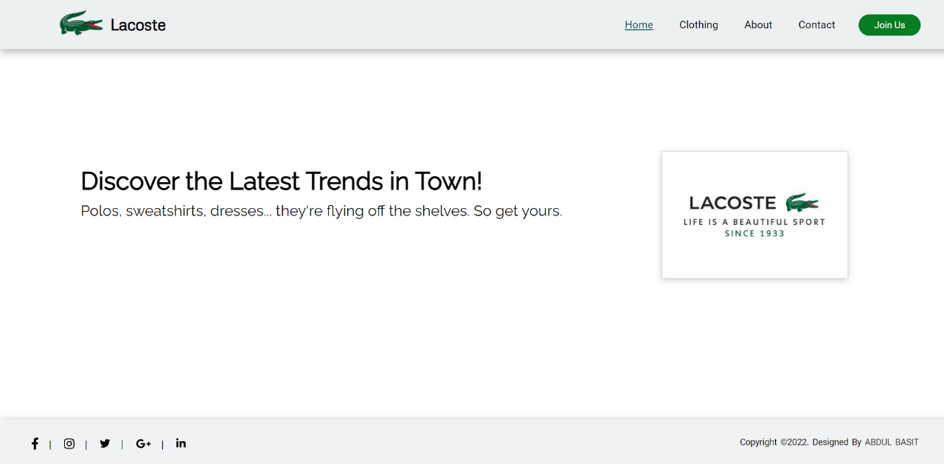

Clothing Page:

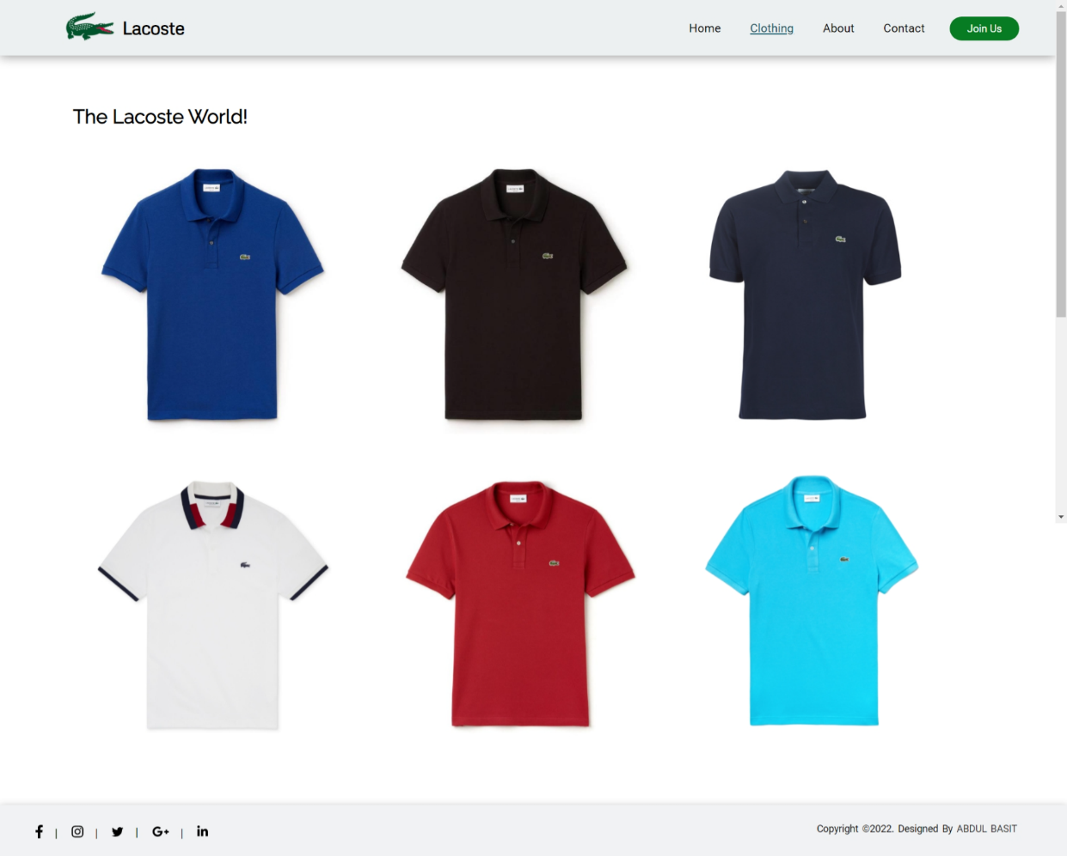

About Page:

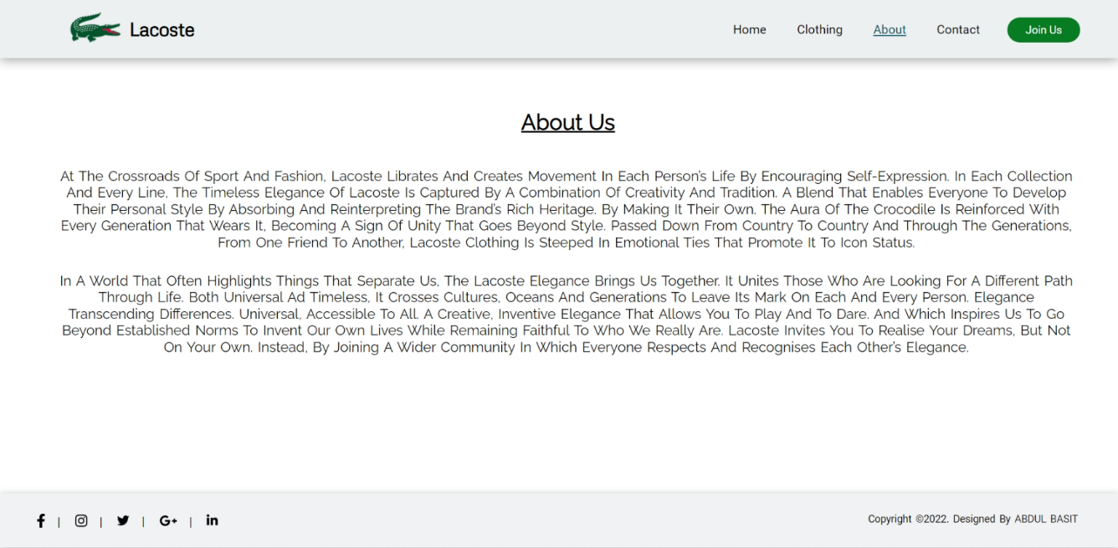

Contact Page:

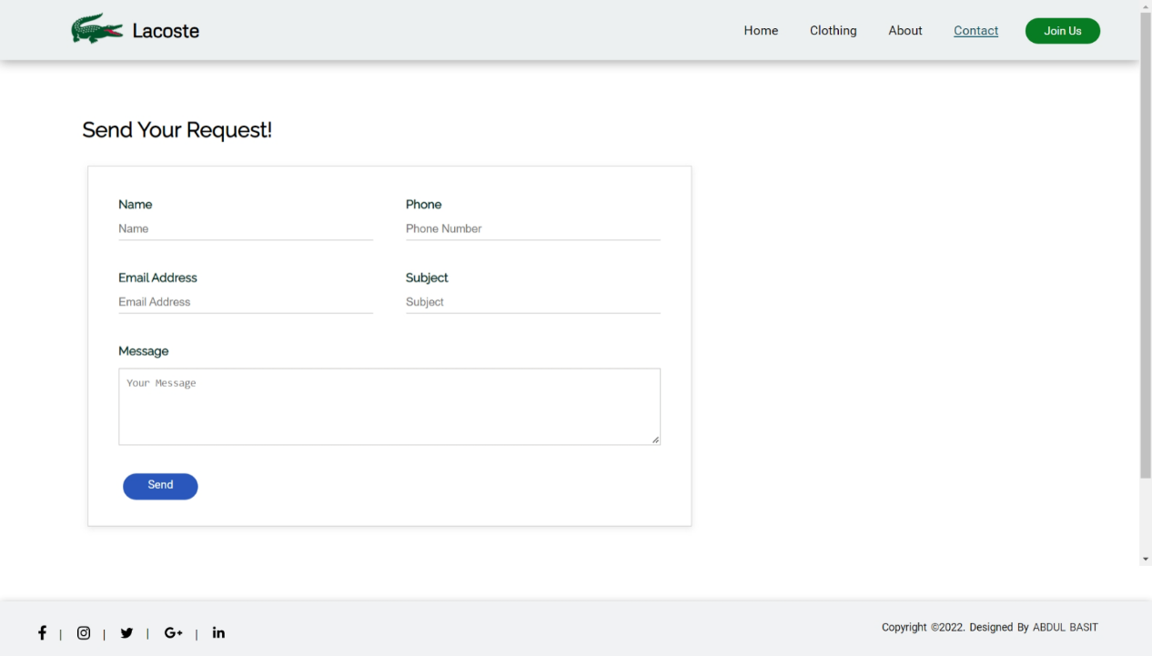

Register Page:

